Assignment-1

Q. The assignment contains a file. Read the file as a dataframe in python. List the type of data that each column represents. Finally, use the proper measure of central tendency for each. What do you think of the missing value?

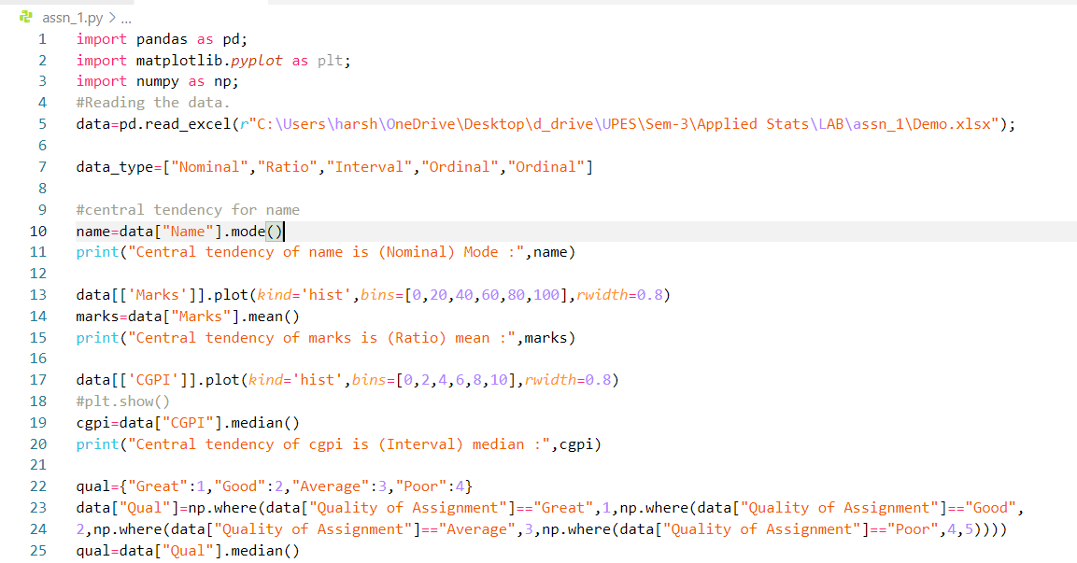

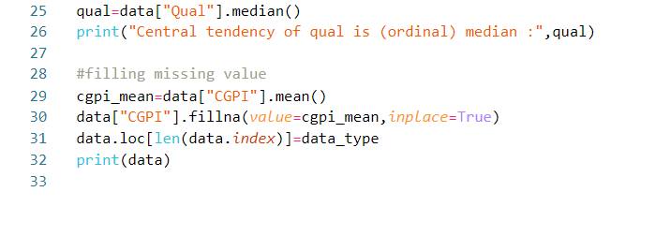

Result:

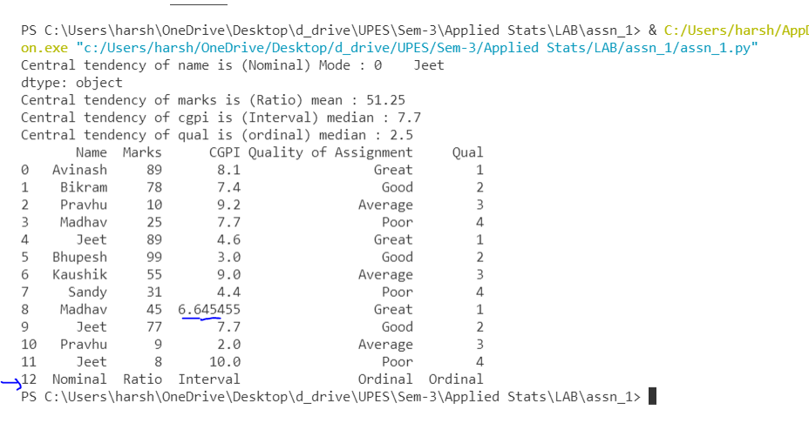

Description:

I first checked for the data types. Regarding (nominal,ordinal,interval,ratio)

Then I calculated central tendency according to their types

But for Marks and CGPI I first made a histogram to check their proportion for the skewness of the graph.  
  
As marks wasn’t skewed so I find mean of the marks column.  
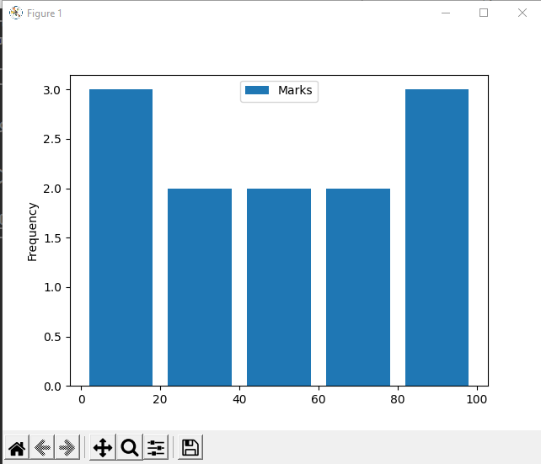

But

As Cgpi is more skewed to the right so I found median for the CGPI column.

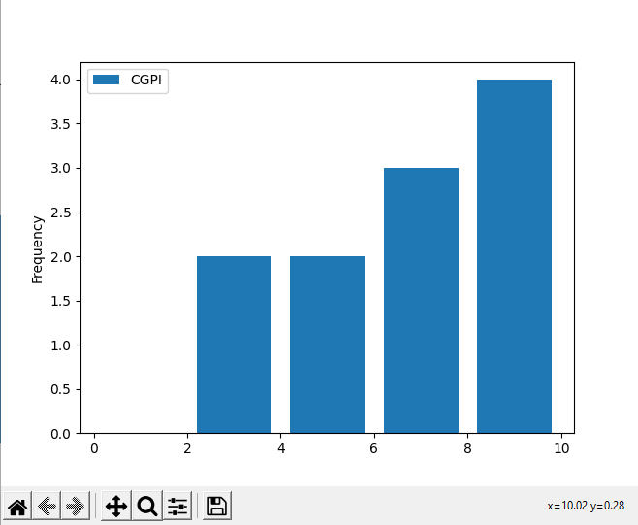

Then added the missing value of Student name Madhav by using mean of the marks column.